Insurance & Retirement Services
Messaging Dashboard Quick Reference Guide
April 9, 2020

© 2020 The Depository Trust & Clearing Corporation. All rights reserved.
The services described herein are provided under the “DTCC” brand name by certain affiliates of The Depository Trust & Clearing Corporation (“DTCC”). DTCC itself does not provide such services. Each of these affiliates is a separate legal entity, subject to the laws and regulations of the particular country or countries in which such entity operates. Please see www.dtcc.com for more information on DTCC, its affiliates and the services they offer.

Doc Date: April 9, 2020
Publication Code: IRS101
Service: Insurance & Retirement Services
Title: Messaging Dashboard Quick Reference Guide

Table of Contents
Introduction 4
Logging In 5
Entering Messaging Dashboard via MyDTCC 6
Select TAG (Transaction Account Group) 8
Selection Screen 9
Send Simulated Message 10
Send Simulated Message Confirmation 11
Search Messages 12
Search Messages Form 13
Search Messages Results 14
Search Messages Request Status 15
Search Messages Field Definitions Document 16

Introduction
This guide will show you how to log in and use the Messaging Dashboard application. The Messaging Dashboard application allows users to search for messages or send simulated messages for Fund Transfers, Attachments, Withdrawals, and Arrangements.

Logging In
Start by logging into the DTCC Portal (located at https://portal.dtcc.com/).
- Type in your User ID and Password in their corresponding fields.
- Click Login to enter the system.
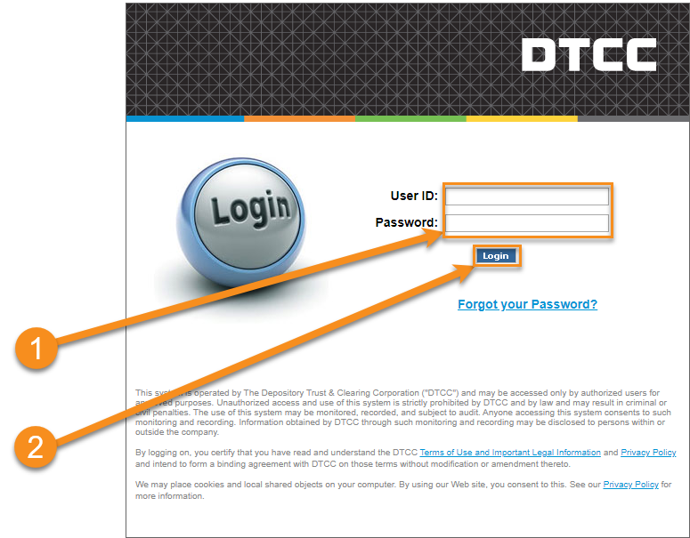

Entering Messaging Dashboard via MyDTCC
- Click Insurance & Retirement Services in the Production or PSE (Test) environment to enter the application.
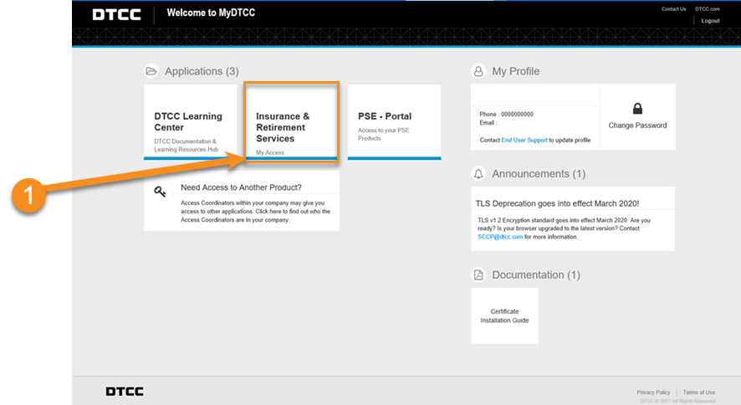
You will be brought to the My Access portal screen. Here you can select Messaging Dashboard as well as other Insurance & Retirement Services applications.

- Click Messaging Dashboard to access the application.

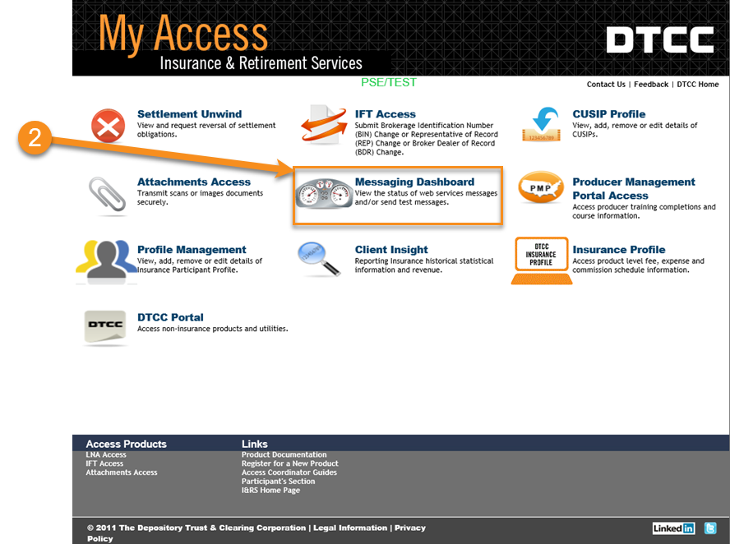

Select TAG (Transaction Account Group)
The Select TAG screen appears if there is more than one participant number. If there is only one participant number, the Selection screen appears instead.
- Select a Transaction Account Group.
- Click Submit.

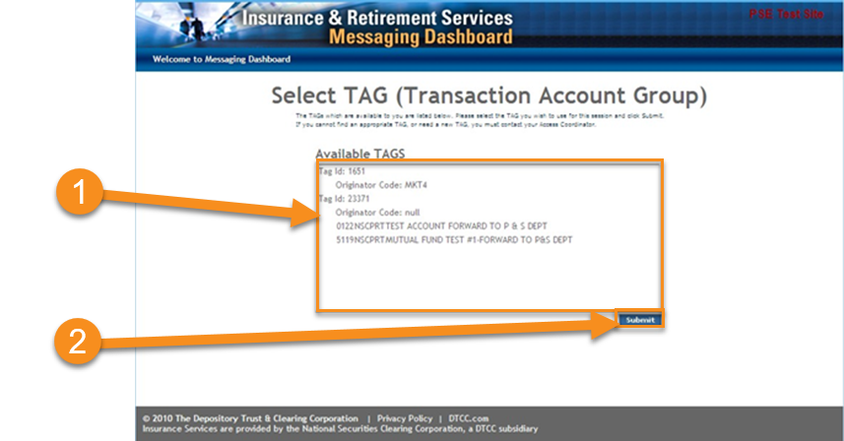

2

Selection Screen
The Selection screen appears. This screen allows you to either send or search messages. Once you select an option, click Submit. The options for that selection will appear.
- Select Send Messages or Search Messages.
- Click Submit.
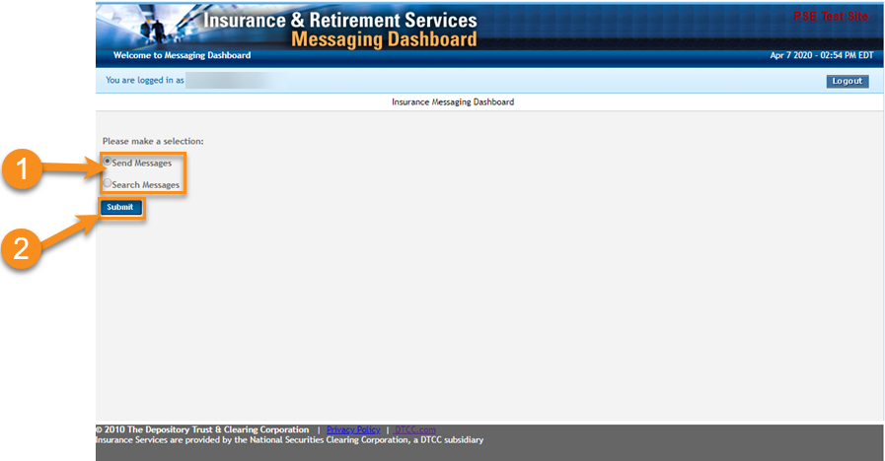

Send Simulated Message
After clicking Submit to send a simulated message on the Selection screen, the Send Simulated Message screen will appear. Here you can submit different types of messages; Fund Transfers, Attachments, Withdrawals, and Arrangements. Only one type can be submitted at a time. The URL indicates where the destination of the message will be.
- If you have more than one participant, select a participant number from the drop-down and click Continue.
- Select the Type of Fund Transfer, Attachment, Withdrawal, or Arrangement message.
- Click Submit.

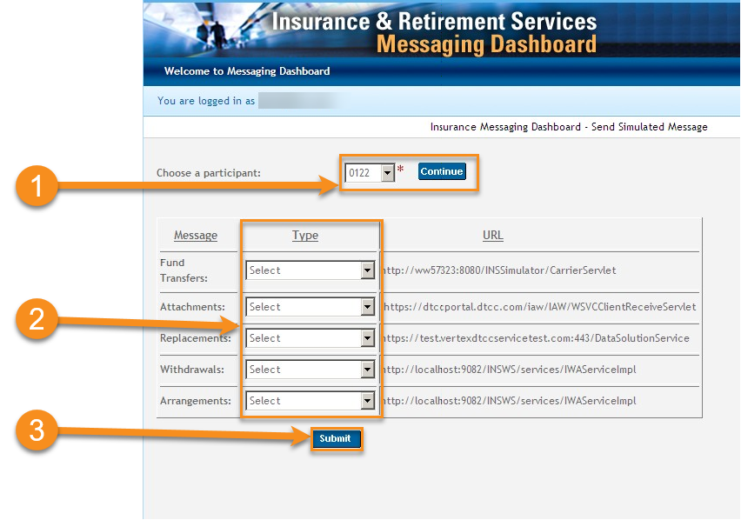 | Fund Transfers  - Values Inquiry (VI)  - Fund Transfers (FT)  - FT Cancel  Attachments  - New Business 103  Withdrawals  (with or without Attachments)  - 105  Arrangements  (with or without Attachments)  - 107

Send Simulated Message Confirmation
- A confirmation displays on the next page telling you if the message was successful or rejected.
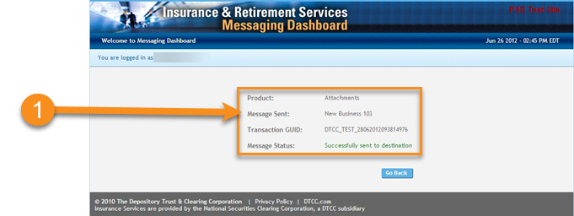

Search Messages
After clicking Submit to search messages on the Selection screen, the Search Messages screen will appear. Here you can search for all IFT Transaction Type and Attachments messages. You can select one or more types to view at a time.
- Select the type of message you want to search for.
- Click Submit.
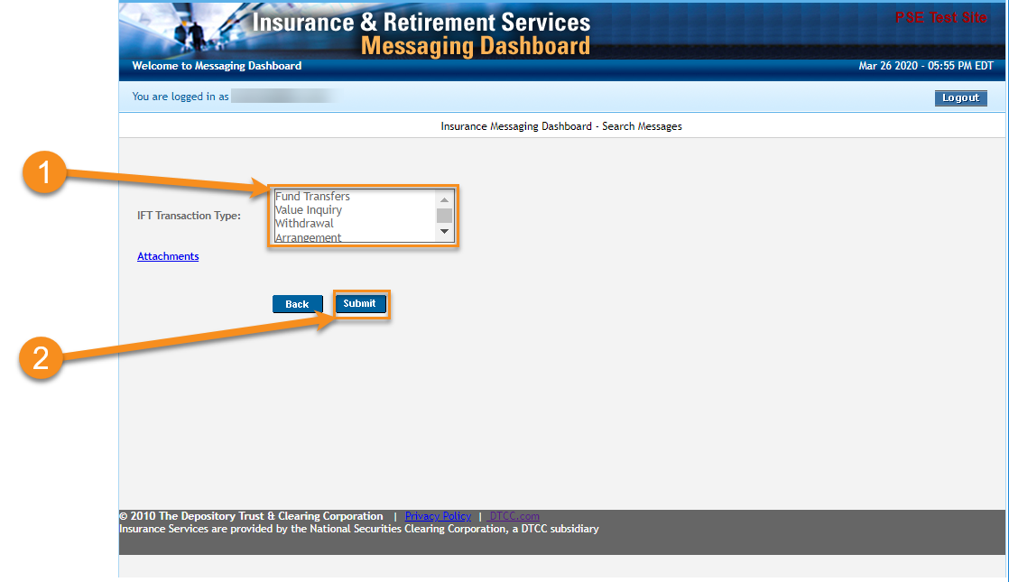

Search Messages Form
- Choose a starting date for the search range.
- Choose an ending date for the search range.
Searching for a blank/optional date will automatically search back 90 days from current date.
Note:
For all transaction types, the span between dates can only go up to 90 days.
- Select a Participant Number or type in a Contra Participant Number and select a Participant Indicator.
Note:
You can further narrow your search by filling out the other fields as well (i.e.: Transaction Reference GUID).
- The Response Status (for Accepted Requests Only) field will allow you to search for either All, Accepted, Rejected, or Timeout messages only.
- Click Search and the results will appear.

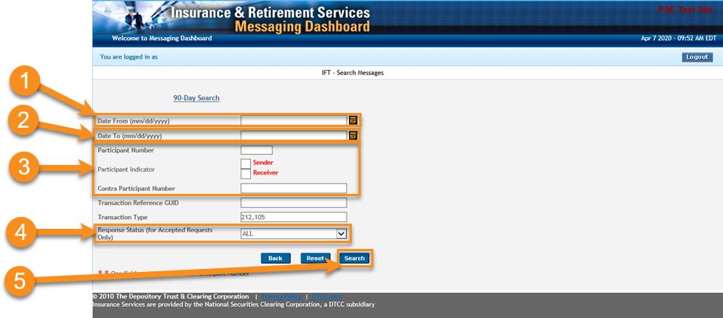

Search Messages Results
- The results from the search are displayed here. You can sort the results with each column heading.
Note:
Columns will vary depending on product line.
- You can export the search results to CSV, Excel, or PDF.

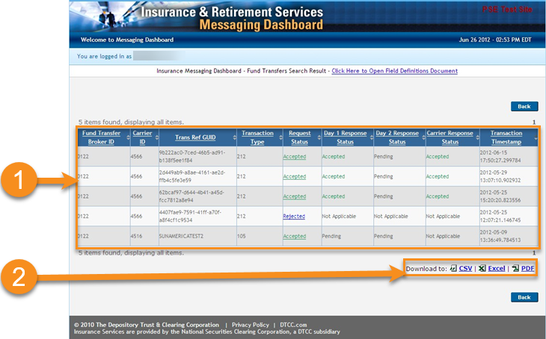

Search Messages Request Status
On the Results screen, you can click the request status.
You can click the arrows on the column header to order the table by that column.
- Click either Accepted or Rejected under Request Status column.

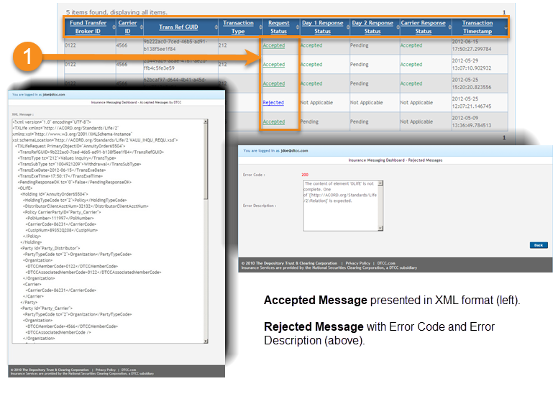

Search Messages Field Definitions Document
You can find the Field Definitions Document on the Search Result screen.
- Click Click Here to Open Field Definitions Document to open the PDF.

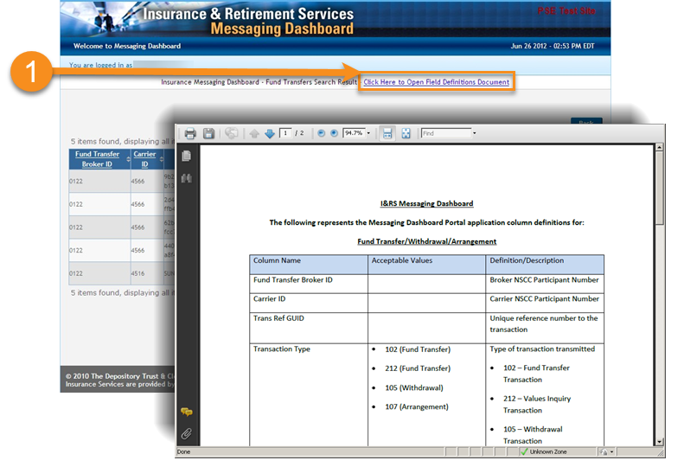

For more information

Email DTCC Learning at:
CoreLearning@dtcc.com
or visit us on the web at:
www.dtcclearning.com

