updating and Posting operational forms

Operational forms can be in the form of a GTR Onboarding Questionnaire Form or a Product Administrator Request Form.

The GTR onboarding form is the most commonly updated form. This will come through the Digital Marketing Request Queue and should include a zipped folder with all assets. You might want to set up a separate folder to store and unzip all the files in one location. Depending on what that team wants to update, the files could include HTML files for the form and Thank You page. It could also include the JavaScript file and the CSS file. Below is an example list of all of those files.

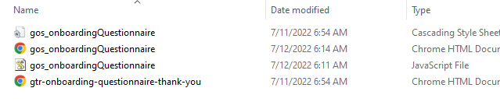

Look in Sitecore for the Forms folder. Down that list of files, you’ll see the “GTR Onboarding Questionnaire” file.
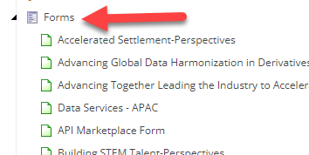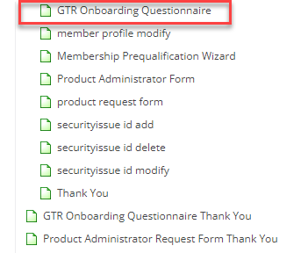

Go to the Body Content section and select HTML view.
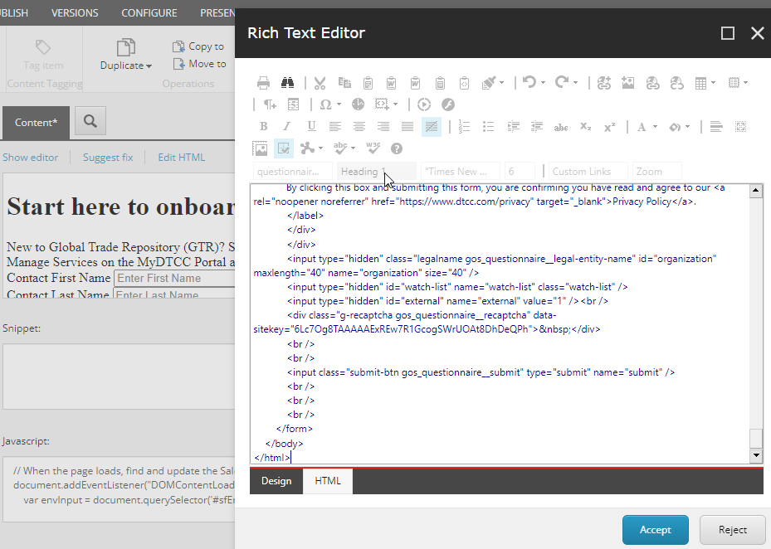

Open the HTML file for the form and right-click on “View Page Source.” Copy all the HTML code.

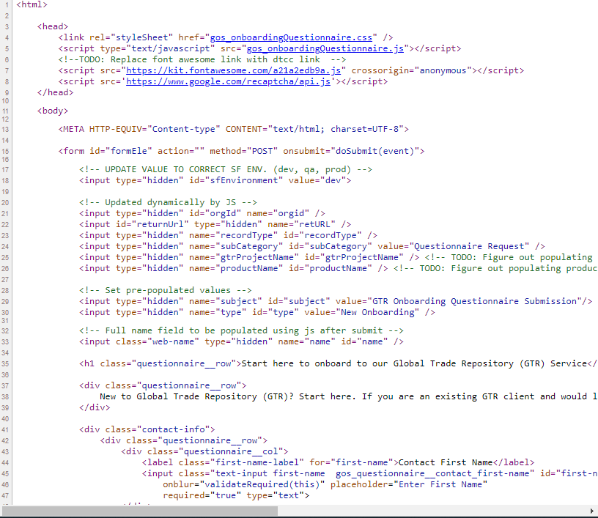

Go to the HTML view of the form in Sitecore, delete the pre-existing content and paste the new code. Press “Accept.”

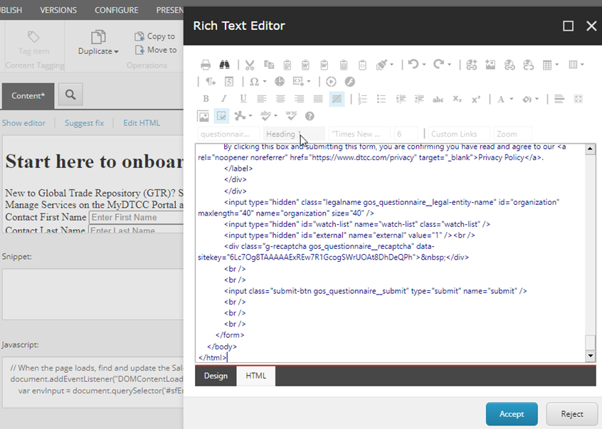

If applicable, do the same steps for the Thank You page.

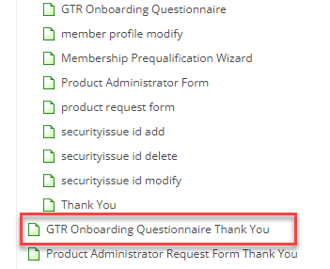

If the zip file also includes a JavaScript file and/or a CSS file, you would first need to open those files with Notepad.

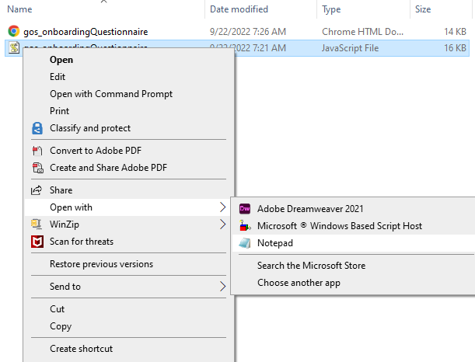
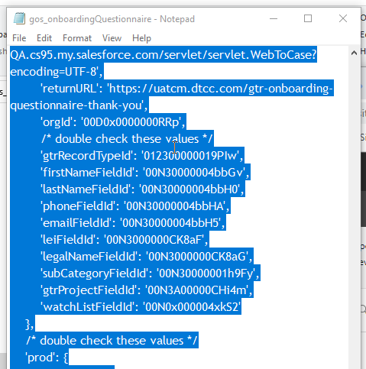

Copy all of the code on the notepad and paste them in one of two locations; the Javascript section and/or the CSS Script of the form.
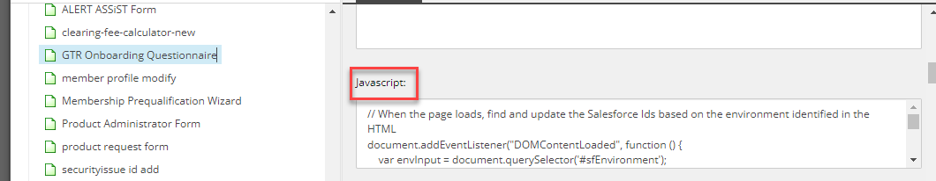

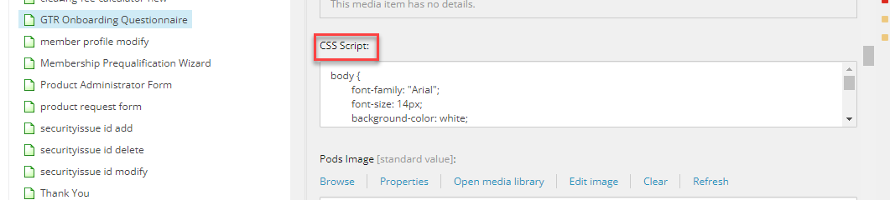
Save all of these changes on the Form and the GTR Onboarding Questionnaire Thank You, if that is part of their request. This includes updating the JavaScript and the CSS file code. The JavaScript and the CSS need to match on the form page and Thank You page.
Publish to staging site and provide the URL https://uatcm.dtcc.com/sitecore/shell/Applications/Content%20Editor.aspx?sc_bw=1 for the requestor to test. If approved, you can then publish form and Thank You page (if requested) to production site.
If you need to create a new form, go to the Forms folder, right-click and select “Content Page.” Then repeat the steps for opening file and copying and pasting source code. Alternatively, you can also create a duplicate of an operational form, change the name of the file and swap out the details.
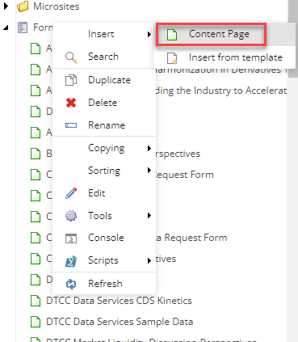

The Dev and QA sites should not be used for internal use like operational forms. These environments are meant to be used between our CMS vendor and the Digital Marketing team. Their intended use is to test updates to our website and web content management system (CMS) that our vendor makes at our request. We need to make sure that our requested enhancements, updates and fixes can be tested in the Dev and QA environments before our vendor pushes those changes to our live site and our production CMS.

This is different than how we might test product interface updates internally. Oftentimes, the Dev and QA environments for www.dtcc.com will not always reflect all of our updates or aspects of our website so they are not appropriate nor in a state to test simple updates that should be isolated to the staging site for testing your forms.
Change Date | Made By
9/22/2022 | Kandee Newell

