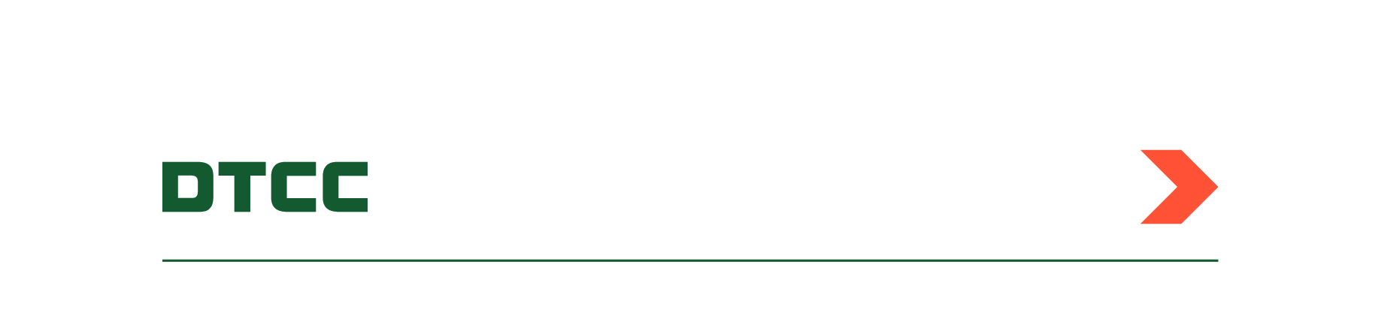

CFTC Clearing Exemptions Service

Submission of CFTC End User and Inter-Affiliate clearing exception/exemption information to DTCC Data Repository (U.S.) LLC (DDR) is done through DDR’s self-service platform, Manage Services. For guidance on submitting clearing exception/exemption information via Manage Services, please refer to the following documentation available on DTCC’s Learning Center:

* [Manage Services: CFTC Clearing Exemptions](https://dtcclearning.com/helpfiles_secure/rds/manage_services/Content/Topics/mngsvc/coveo_exclude/cftc_clearing_cp.htm)

*For additional information, please contact*[*gtr-onboarding@dtcc.com*](mailto:gtr-onboarding@dtcc.com)*.*